1. Once you are in edit mode on the Sites page, click the page option (highlighted) next to the Customize tab.

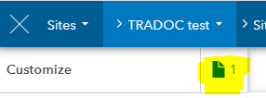

1. Click “New Page”

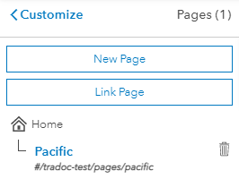

1. Name the page and then hit Next. This will create a new page with elements for your Site.
2. Delete all the extraneous elements by hovering over them and clicking the trashcan icon.
3. On the customize pane, select Layout
4. Find the “Gallery” Option and drag it to your page

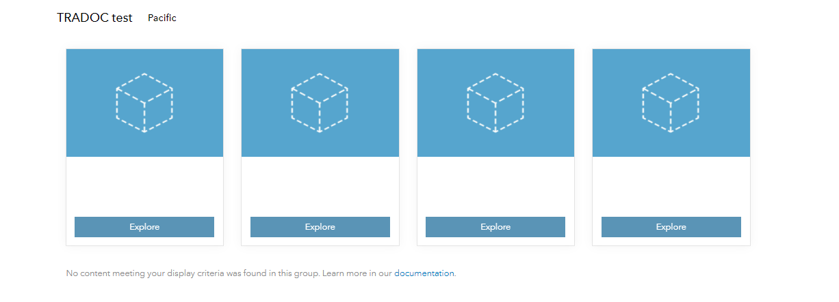

1. On the layout pane on the left side of the screen, switch the display option from Dynamic to Manual.

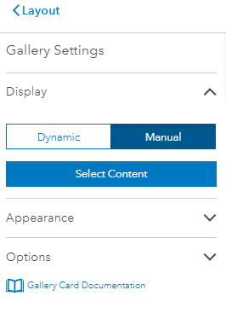

1. Click “Select Content”
2. In the search bar, search for the data you would like to display. For example “[TRADOC G2 DATE Africa Home Station Exercise 2 SFAB](https://agewebportal.erdc.dren.mil/portal/apps/sites/#/tradoc-exercise-support/datasets/3c6a40e5528c4fb795d75938ef21507c)”. Make sure that since this is a map, you select map as the “collection type”.
3. Once the correct layer has come up, select it by checking the box next to it’s name and then click select down at the bottom of the window.

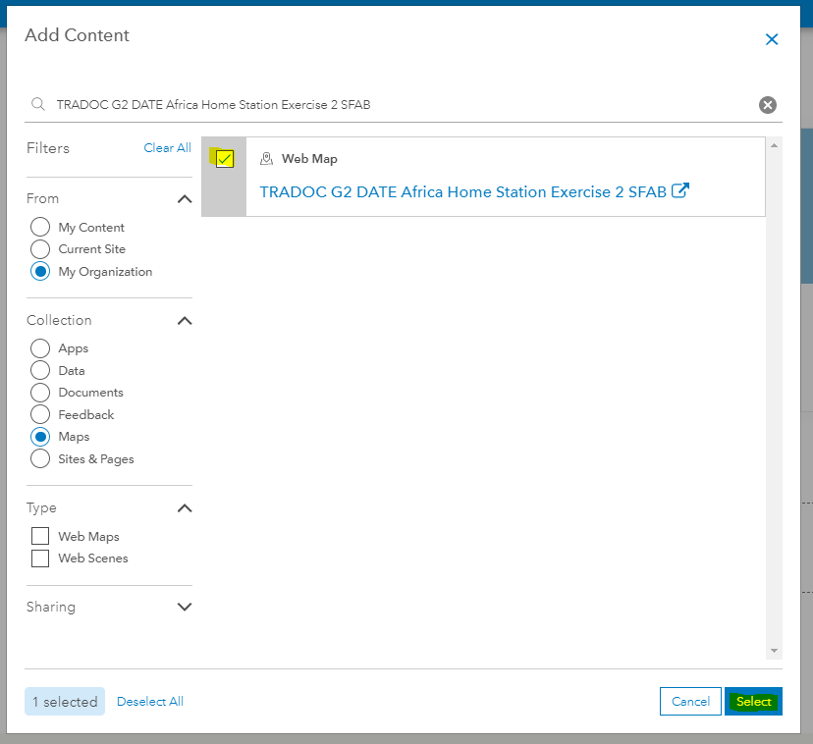

1. This data should now appear in your gallery. Repeat these steps for the rest of the data you would like to add. Keep in mind that a gallery can only hold 16 cards, so if you need to add additional data/cards you will need to add another gallery element to the page.

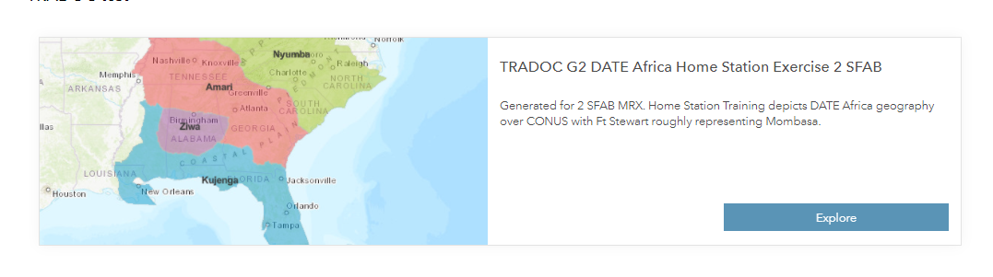

1. Save your edits.
2. Go back to the main page of your Site.
3. On the customize pane, expand the “Header” option.
4. Expand the “Menu” Option and click to “Add Link”🡪 to existing content.
5. Under “Collection” select “Site & Pages” and find the new page you created.
6. Select the appropriate page and click select at the bottom of the Add Content screen.
7. You should now see an additional page listed.

